### **Bug:**

A bug is the consequence/outcome of a coding fault.

### **Defect:**

A defect is a variation or deviation from the original business requirements.

# **Defect Life Cycle or Bug Life Cycle:**

Defect/Bug Life Cycle or Bug Life Cycle is the specific set of states that a Bug goes through from discovery to defect fixation.

* ****New:**** When a new defect is logged and posted for the first time. It is assigned a status NEW.
* ****Assigned:**** Once the bug is posted by the tester, the lead of the tester approves the bug and assigns the bug to developer team
* ****Open****: The developer starts analyzing and works on the defect fix
* ****Fixed****: When developer makes necessary code change and verifies the change, he or she can make bug status as "Fixed."
* ****Pending retest****: Once the defect is fixed the developer gives particular code for retesting the code to the tester. Since the testing remains pending from the testers end, the status assigned is "pending request."
* ****Retest****: Tester does the retesting of the code at this stage to check whether the defect is fixed by the developer or not and change the status to "Re-test."
* ****Verified****: The tester re-tests the bug after it got fixed by the developer. If there is no bug detected in the software, then the bug is fixed and the status assigned is "verified."
* ****Reopen****: If the bug persists even after the developer has fixed the bug, the tester changes the status to "reopened". Once again the bug goes through the life cycle.
* ****Closed****: If the bug is no longer exists then tester assigns the status "Closed."
* ****Duplicate****: If the defect is repeated twice or the defect corresponds the same concept of the bug, the status is changed to "duplicate."
* ****Rejected****: If the developer feels the defect is not a genuine defect then it changes the defect to "rejected."
* ****Deferred****: If the present bug is not of a prime priority and if it is expected to get fixed in the next release, then status "Deferred" is assigned to such bugs
* ****Not a bug****:If it does not affect the functionality of the application then the status assigned to a bug is "Not a bug".

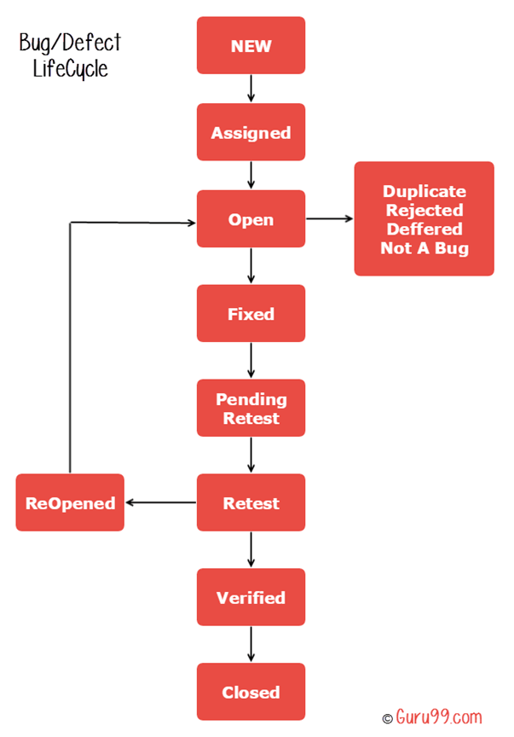

**Bug Tracking Tools**:

1. Bugzilla
2. JIRA
3. REDMINE
4. TARC
5. MANTIS...etc

**Severity & Priority in Testing:**

**Severity:**

Severity is defined as the degree of impact a[Defect](https://www.guru99.com/the-unconventional-guide-to-defect-management.html)has on the development or operation of a component application being tested.

*Defect severity can be categorized into four class*

* ****Critical****: This defect indicates complete shut-down of the process, nothing can proceed further.
* ****Major****: It is a highly severe defect and collapse the system. However, certain parts of the system remain functional.
* ****Medium****: It cause some undesirable behavior, but the system is still functional.
* ****Low****: It won't cause any major break-down of the system.
* During UAT the development team fix defects based on priority.

**Priority:**

Priority is defined as the order in which a defect should be fixed. Higher the priority the sooner the defect should be resolved.

*Defect priority can be categorized into three class*

* ****Low:****The Defect is an irritant but repair can be done once the more serious Defect have been fixed.
* ****Medium:****During the normal course of the development activities defect should be resolved. It can wait until a new version is created.
* ****High:****The defect must be resolved as soon as possible as it affects the system severely and cannot be used until it is fixed.
* During SIT(System Integration Testing), the development team will fix defects based on the severity and then priority.